5E Lesson Plan Template
Teacher
Subject area/course/grade level | Physical Education 5th Grade
Standards (State and ISTE Standards for Students) | Alabama State Department of Education (ALSDE) Physical Education Standard  Standard 5-5.2: Create a visual product or written essay about the enjoyment and/or challenge of participating in a favorite physical activity. Examples: poster, drawing, comic strip, creative dance, skit, media presentation  ITSE Standards  1.1a Students connect their learning needs, strengths and interests to their goals and use technology to help achieve them and reflect on their progress.  1.3 Students recognize the rights, responsibilities, and opportunities of living, learning, and working in an interconnected digital world and act in ways that are safe, legal, and ethical.
Objectives | - Participate in a variety of physical activities with effort and positive behavior.  - Reflect on their personal enjoyment of different physical activities.  - Rate each physical activity using a structured rating scale.  - Use a digital tool responsibly to communicate preferences and reflect on physical activity choices.
Differentiation Strategies: How will the lesson address the various learning styles of the students and the needs of those with special needs? | - Support: Modified movements, shorter activity times, peer assistance  - Challenge: Student leaders help demonstrate or explain stations  - Accessibility: Choice of movement options within each station

The 5 Es
E | Description
Engagement | Students complete a dynamic warm-up including:  - Jogging or walking laps  - Arm swings and leg stretches  - Light jumping or skipping  Teacher-led discussion:  - “Which activity do you enjoy most?”  - “Which skill is hardest: jumping, throwing, or balancing?”
Engagement Assessment | - Google Form responses to check prior knowledge  - Teacher observation of participation and responses
Exploration | Students will:  - Demonstrate motor skills (jumping, throwing, locomotor movement)  - Practice safe and respectful behavior  - Evaluate activities using simple feedback tools  - Use technology to reflect and assess performance  Station Overview (4 Stations, 5–8 min each)  1️ Jump Rope Station  Activity:  - Individual jumping (basic, alternating feet)  - Partner challenges (synchronized jumping, counting streaks)  Teaching Points:  - Rhythm and coordination  - Controlled movement  Technology Integration:  - Use a tablet/phone to record short videos of students  - Students watch their form and identify 1 improvement  - Optional: Use slow-motion replay  App ideas:  - Camera app  2️ Throw & Catch Station  Activity:  - Throw foam balls at wall targets or buckets  - Partner toss and catch  Teaching Points:  - Hand-eye coordination  - Proper throwing technique  💻 Technology Integration:  - Youtube video posted on Google Classroom station linking to a demo video  - Use a Google Form to track:  - “How many targets did you hit?”  Adds self-assessment + data tracking  3️ Hula Hoop Station  Activity:  - Waist hooping  - Arm rotations  - Rolling hoops on floor (control + chasing)  Teaching Points:  - Body control and balance  - Core strength  Technology Integration:  - Students watch Youtube video at this station for demo.  - Use a timer app to track how long they can keep hoop going  Students can try to beat their own score  4️ Fitness Movement Station  Activity:  - Skipping  - Side-shuffling  - Balance walks  - Cone movement patterns  Teaching Points:  - Locomotor skills  - Agility and balance  Technology Integration:  - Play movement videos on a screen/tablet  - Use interval timer app for rotations (30 sec each movement)  Keeps students engaged and structured  Students complete a quick form (Google Form):  Questions:  - Which station did you like best?  - Which was most challenging?  - Did you try all stations? (Yes/No)  - Rate each station (1–5)  This reinforces your requirement:  “Trying each activity before rating it”  - Students watch their jump rope or throwing video  - Answer:  - What did I do well?  - What can I improve?  Digital citizenship in the lesson:  - Respect: Recording others respectfully  - Responsibility: Using devices appropriately  - Safety: No misuse of equipment or technology  - Digital Footprint: Videos are for learning, not sharing without permission  Before starting, review:  - Safe participation (space, control, equipment use)  - Respect for others (encouragement, no teasing)  - Effort (try every station before rating)  - Responsible technology use  - Assign 1 student per group as tech helper  - Use timers or music to signal rotation  - Keep devices at stations (not in hands constantly)  - Use numbers on each station for quick access to Youtube videos.  Ask:  - “Which station helped you improve the most?”  - “How did technology help you today?”  - “What skill do you want to practice more?”
Exploration Assessment | - Teacher observation checklist:  - Participation  - Effort  - Safety  - Cooperation  - Peer feedback discussions
Explanation | Key Concepts  - Safety (space awareness, controlled movement)  - Respect (encouragement, teamwork)  - Effort (trying all stations)  - Skill technique (throwing form, rhythm, balance)  Technology Tool: Google Slide Presentation  The teacher uses Google Slides to present:  - Skill breakdowns  - Interactive questions  - Quick checks for understanding  Alternative tools: Canva presentation  Higher Order Thinking Questions  - Why is it important to try every station before rating it?  - How can technology help improve your physical skills?  - What strategies helped you improve your performance?
Elaboration | Students apply learning through two technology-based assignment options.  Assignment 1: Reflection Video or Form  Students complete one of the following:  - Record a short video reflection  OR  - Complete a Google Form reflection  Questions:  - Which station did you like best and why?  - What skill did you improve?  - How did you use technology to learn?
Evaluation | - 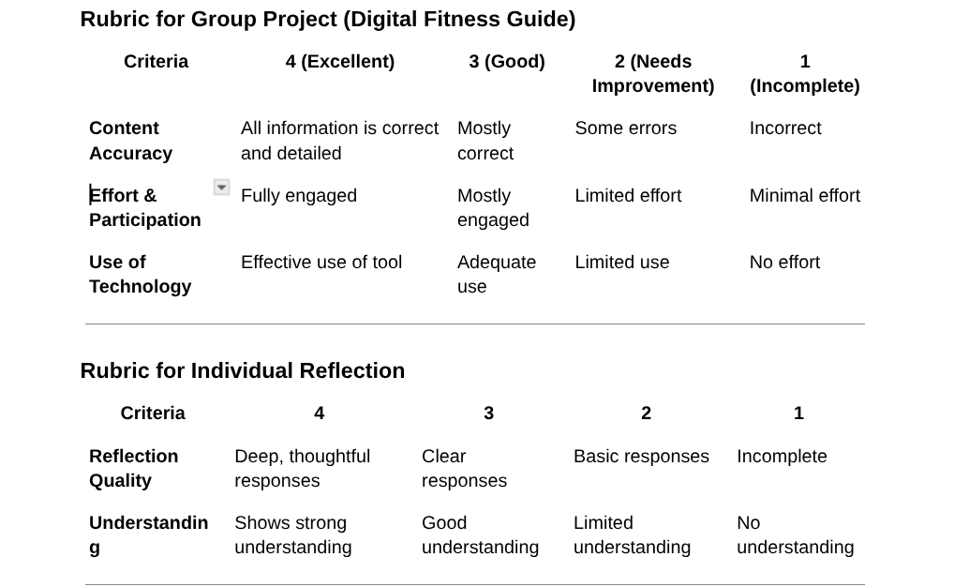
Evaluation Assessment | - Completion of all stations  - Participation and effort  - Quality of reflection  - Demonstration of skills  - Appropriate use of technology

References
Bybee, R.W. et al. (1989). Science and technology education for the elementary years: Frameworks for curriculum and instruction. Washington, D.C.: The National Center for Improving Instruction.
Bybee, R. W. (1997). Achieving Scientific Literacy: From Purposes to Practices. Oxford: Heinemann.
National Research Council. (1999). Inquiry and the national science education standards: A guide for teaching and learning. Washington, D.C.: National Academy Press.
Polman, J.L. (2000). Designing project-based silence: Connecting learners through guided inquiry. New York: Teachers College Press.

